**Checkpoint mongo**

Crée dossier dans C:/

data => db

puis dans cmd

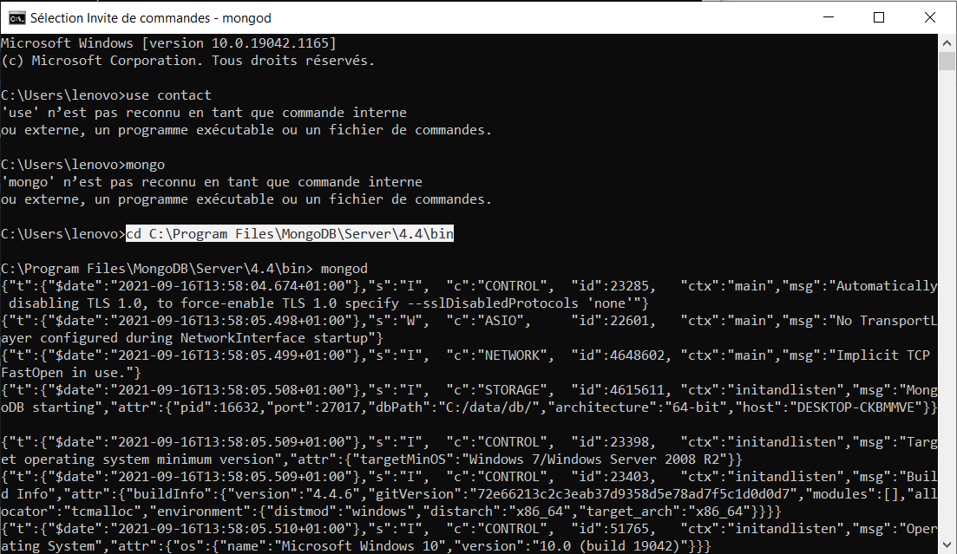

Autre cmd

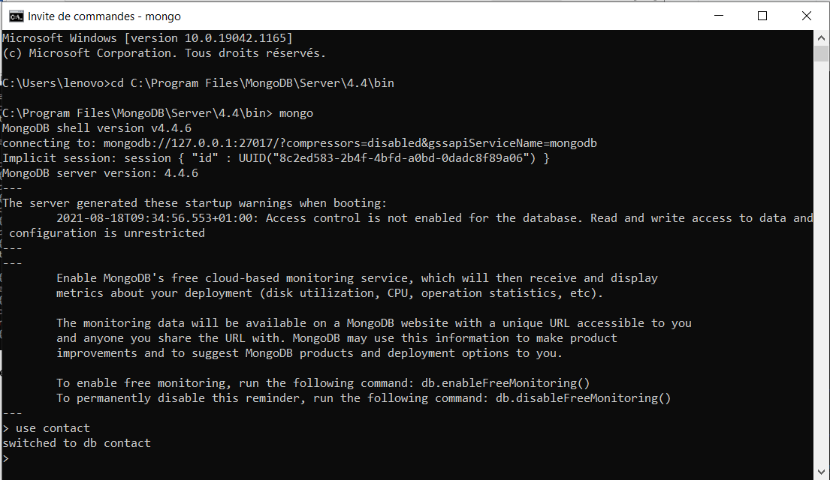

db.contactlist

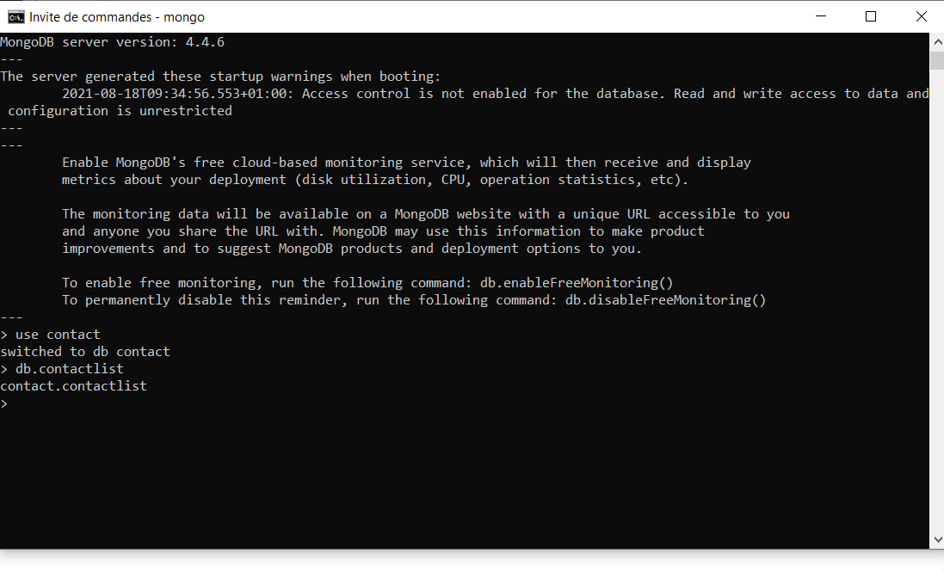

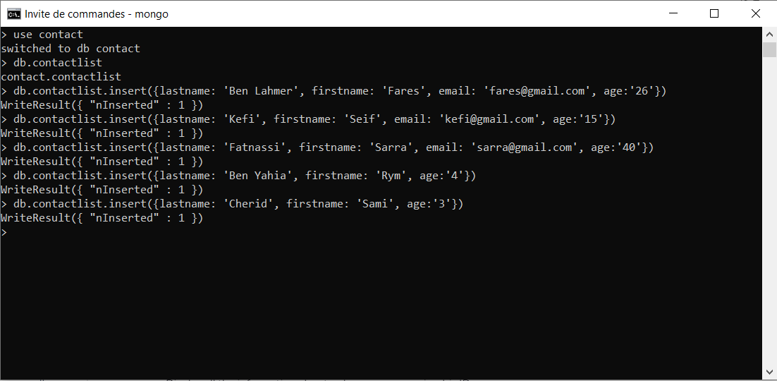

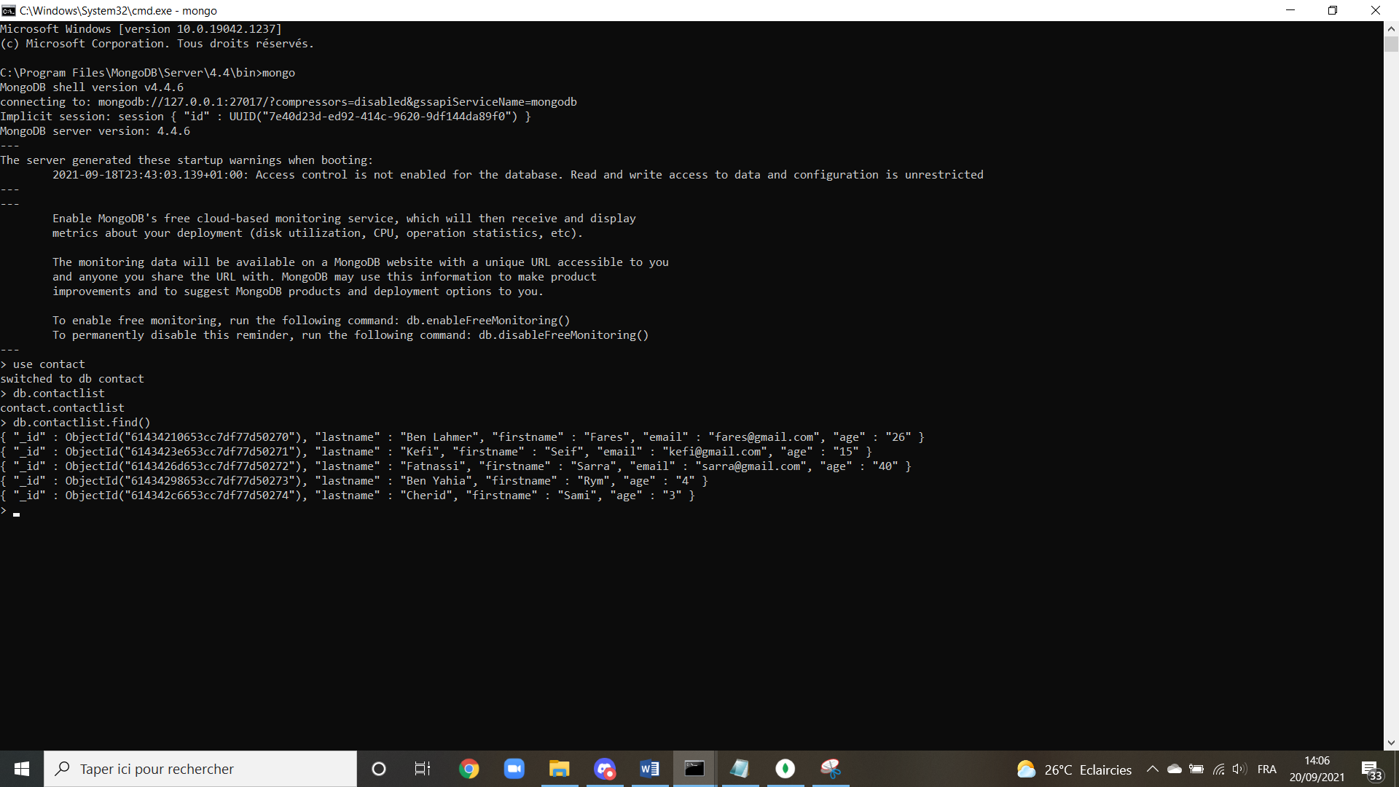

* Display all the information about only one person using his ID.



* Display all the contacts with an age >18.

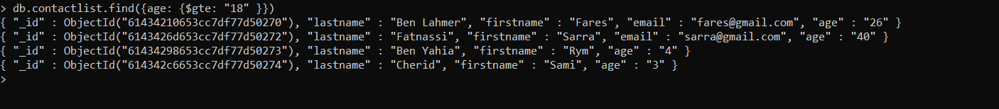

* Display all the contacts with an age>18 and name containing "ah".

db.contactlist.find({age:{$gte:"18"}, "lastname": {$regex: "ah"}})



db.contactlist.findOneAndUpdate({"lastname": "Kefi"}, {$set :{"firstname": "Anis"}})

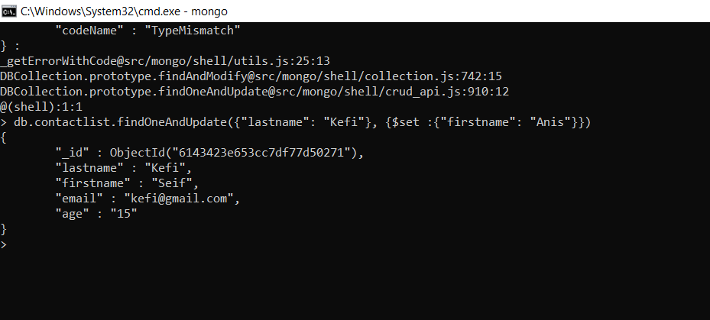

db.contactlist.deleteMany({age:{$lt:5}})

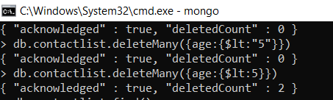

db.contactlist.find()

